[2022-12-06-CONSIL_ST_15698_2022_INIT_EN_TXT.docx (live.com)](https://view.officeapps.live.com/op/view.aspx?src=https%3A%2F%2Fraw.githubusercontent.com%2Fsmucclaw%2Feu-ai-act%2Fmain%2Finput-docx%2F2022-12-06-CONSIL_ST_15698_2022_INIT_EN_TXT.docx&wdOrigin=BROWSELINK)

Table of Contents

What I’ve done 1

I. Anomalies in the diffs (I’m using the ‘unified’ view) 1

Footnotes occasionally get picked up 1

Missing indent 2

Signatures 4

II. Errors in the diff 5

Incorrect numbering notation 5

## What I’ve done

* Deleted extra line spacings between paragraphs, where it affects the diffs (unless that causes the main text to go into the footnote area).
* Deleted line spacing within paragraphs
* Note: my main focus is on looking for section / line break errors rather than errors *per se* (so I might have missed out on more errors).

## I. Anomalies in the [diffs](https://github.com/smucclaw/eu-ai-act/commit/115bab65e0822980b822ab6b65882fda0ef35a0b) (I’m using the ‘unified’ view)

### Footnotes occasionally get picked up

* e.g. Footnote 25 reflected partially in preamble (61)

*Diffs*

*MS Word*

*PDF*

### Missing indent

* e.g. Article 25(2)(-a) to (d). Indent here would help make clear that the text after (d) does not belong to (d). See also Article 53(1b)(a) to (d), Article 53(6)(a) to (c), Annex VII 3.3-3.4, 4.5(a) and (b).

*Diffs*

*MS Word*

*PDF*

### Signatures

* Signatories not represented properly. Hopefully edits to MS Word help.

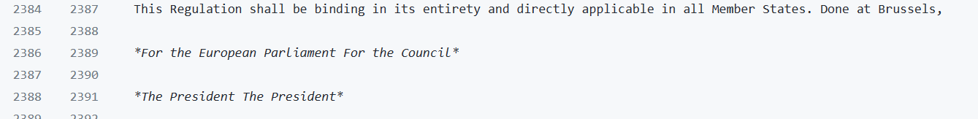

*Diffs*

*MS Word (before edits)*

*MS Word (after edits)*

*PDF*

## II. Errors in the diff

### Incorrect numbering notation

* e.g. Article 7(2)(h)(i) has been represented incorrectly as a separate paragraph 7(2)(i) as well as misalignment issues. See also Annex VII Article 4.6 mislabelled as 4.1; Annex VII Article 4.7 mislabelled as Article 2.

*Diffs*

*MS Word*

*PDF*